# Sorting by Index Values

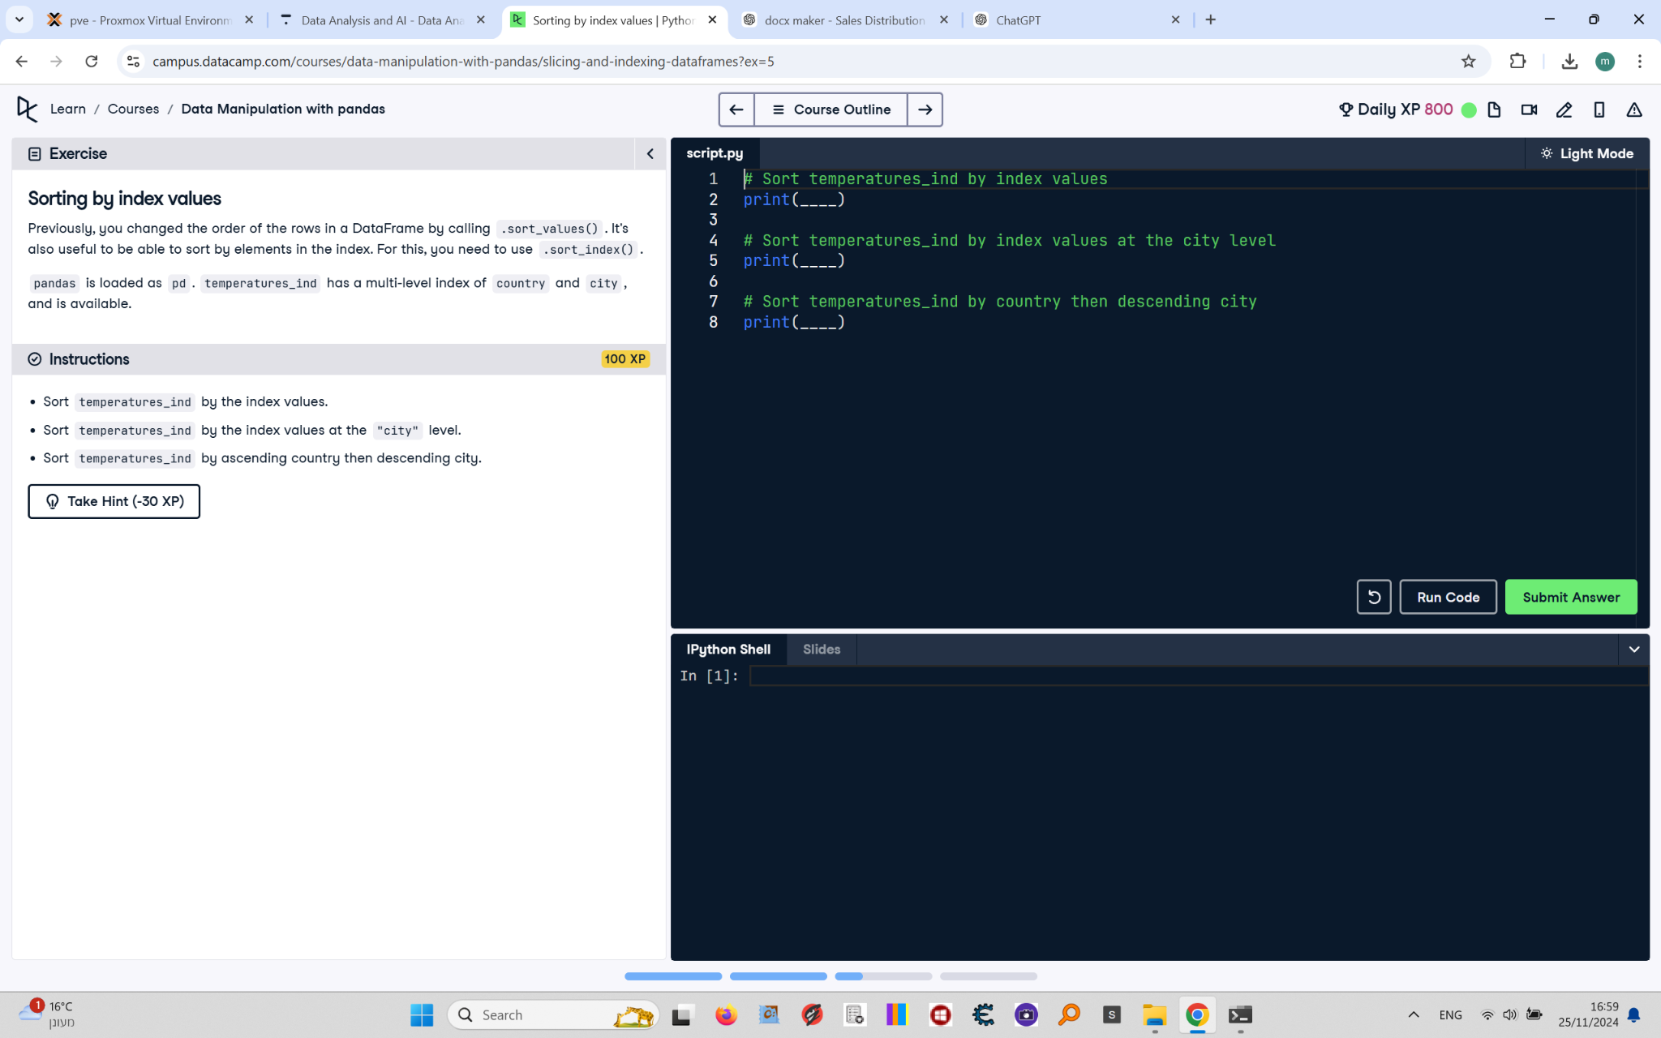

Previously, you changed the order of the rows in a DataFrame by calling .sort_values(). It's also useful to be able to sort by elements in the index. For this, you need to use .sort_index().  
  
pandas is loaded as pd. temperatures_ind has a multi-level index of country and city, and is available.

## Final Answer

# Sort temperatures_ind by index values  
print(temperatures_ind.sort_index())  
  
# Sort temperatures_ind by index values at the city level  
print(temperatures_ind.sort_index(level="city"))  
  
# Sort temperatures_ind by ascending country then descending city  
print(temperatures_ind.sort_index(level=["country", "city"], ascending=[True, False]))